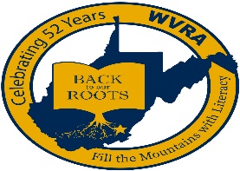
West Virginia Reading Association
Call for CONFERENCE HOSTESSES OR HOSTS

Dear Colleague:
Thank you for volunteering to be a conference hostess or host during the WVRA’s conference. To be a conference hostess or host, you must register and have paid to attend the conference. As a conference hostess or host, you will be an ambassador for the West Virginia Reading Association. Your duties will be to welcome our conference guests, give directions, and answer questions.
The Association does not wish to take away from your valuable conference experience; therefore, please provide the following information to assist us in assigning you a presider time slot, which best suits your conference schedule. Check all that apply.
_____Thursday, November 18, 2021 AM; _____Thursday, November 18, 2021 PM
_____Friday, November 19, 2021 AM; _____Friday, November 19, 2021 PM
_____I am flexible. Please schedule me whenever the WVRA needs me.
_____I am a WVRA Executive Board Member. Do not schedule me during Board functions.

NAME: ___________________________________________________________________
(As it is to appear in the conference program)

Mailing Address: ___________________________________________________________

City: __________________________; State: ________; Postal Zip Code: _______________

E-Mail Address: __________________________________

Preferred Telephone Number: (_____)____________; ____ I can receive text messages at this number.

Best times to contact me, only if necessary________________________________________

Please return this form by either mail or e-mail, on or before August 15, 2021 to

Kathy Blue
1750 Daniel Road
Shenandoah Junction, WV 25442
304-725-4358
kathyjo055@aol.com

